ISO/TC 261 and ASTM F42

Joint Plan for Additive Manufacturing Standards Development

This Additive Manufacturing Standards Development Plan summarizes the results and agreements from joint planning sessions conducted by ISO/TC 261 and ASTM F42 for development of additive manufacturing (AM) standards. The first planning session was hosted by ASTM International in Philadelphia (USA) on June 25-26, 2013. This live and virtual meeting included participants from both ISO/TC 261 and ASTM F42, including the leadership from both committees. The second planning session was conducted during the Nottingham (UK) meetings of ISO/TC 261 and ASTM F42 held during July 10-12, 2013. The July meeting also included participants from both ISO/TC 261 and ASTM F42, including the leadership from both committees.

The Additive Manufacturing Standards Development Plan is considered to be a living document that will be reviewed and updated on a regular basis by ISO/TC 261 and ASTM F42.

Objectives
The objectives of the joint planning sessions and this resulting Standards Development Plan include the following:
- Bring AM industry experts together from ISO/TC 261 and ASTM F42
- Identify specific standards needs common to the AM industry
- Align standards roadmaps, resulting in a joint roadmap common to ISO/TC 261 and ASTM F42 interests
- Determine how the two groups can best work together
- Determine the priorities for specific AM standards

Agreements on Guiding Principles
ISO/TC 261 and ASTM F42 reached several key agreements on the guiding principles to be followed and pursued by both organizations, including the following:
- One set of AM standards – to be used all over the world
- Common roadmap and organizational structure for AM standards
- Use and build upon existing standards, modified for AM when necessary
- For efficiency and effectiveness, ISO/TC 261 and ASTM F42 should begin the work together and therefore in the same direction
  - Emphasis on joint standards development

Structure of AM Standards
In order to develop the common roadmap and organizational structure for AM standards, ISO/TC 261 and ASTM F42 reviewed the status of existing AM standards development pursued by each organization, reviewed existing AM standards roadmap documents, and reviewed existing proposals for the structure and organization of AM standards. The commonality and differences of each candidate structure was discussed and consensus was reached on a common structure for AM standards that addresses the perspectives and requirements from both ISO/TC 261 and ASTM F42.

The agreed-upon common structure defines multiple levels and a hierarchy of AM standards, with the following three levels:
- General standards: standards that specify general concepts, common requirements, or are generally applicable to most types of AM materials, processes, and applications
- Category standards: standards that specify requirements that are specific to a material category or process category
- Specialized standards: standards that specify requirements that are specific to a material, process, or application

The figure below illustrates the agreed-upon common structure of AM standards.

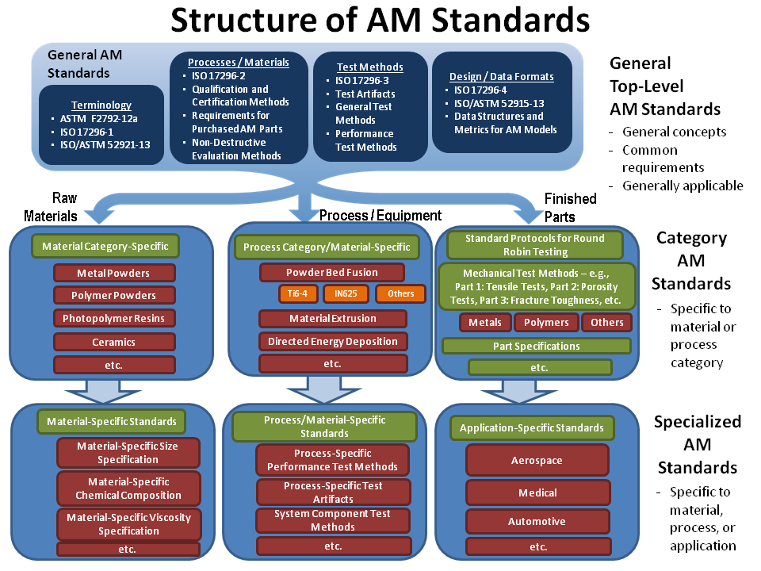

Several usage guidelines are established as follows to facilitate use of the common structure of AM standards:
- The structure diagram is intended as a high-level guide. It may evolve to take into account special circumstances.
- Specific bullet points and words in the blue/green/red/orange “boxes” are examples and placeholders only to indicate the types of standards that may be necessary for that portion of the hierarchy. The specific standards and groupings are yet to be determined.
- Modularized standards are intended. A hierarchy of standards exists to reduce duplication within AM standards. Specifically:
  - Parent/child relations exist between levels (from top to bottom)
  - Characteristics pass from parent level to child level (upon reference)
  - Child level standards can modify or augment the characteristics as needed for the specific use
- The key question relevant to the three possible paths vertically through the hierarchy is:
  - What will the developed standard specify or evaluate? (Raw Materials, Process/Equipment, or Finished Parts)

Additionally, ISO/TC 261 and ASTM F42 intend to evaluate this organizational structure (and update as needed) through further activities to map expected future standards to the structure to assess its completeness and extensibility. Once several modular AM standards exist related to this structure, an informational document will be prepared as an overview “map” of AM standards to improve the usability of the complete set of standards documents for end-users.

Proposed Pilot AM Standards for Joint Development
ISO/TC 261 and ASTM F42 identified a consensus list of high-priority candidates for potential joint AM standards development as follows:
- Qualification and certification methods
- Design guidelines
- Test methods for characteristics of raw materials
- Test methods for mechanical properties of finished AM parts
- Material recycling (re-use) guidelines
- Standard protocols for round robin testing
- Standard test artifacts
- Requirements for purchased AM parts
- Harmonization of existing ISO 17296-1 and ASTM 52912 terminology standards

Though all of these topics are high-priority, the following are chosen by ISO/TC 261 and ASTM F42 to pursue as pilot AM standards for joint development:
- Harmonization of existing ISO 17296-1 and ASTM 52912 terminology standards (to be convened by ISO)
- Standard test artifacts (to be convened by ASTM)
- Requirements for purchased AM parts (to be convened by ISO)
- Design guidelines (to be convened by ASTM)

Due to the importance and continued development of terminology, it is expected that an ongoing joint group on Terminology may be needed at all times.

Cooperation and Collaboration Procedures
Several specific procedures are determined for how ISO/TC 261 and ASTM F42 will cooperate and work together in a practical sense, in accordance with the agreement between ISO and ASTM.

Joint Groups: A joint group (JG) of committed experts will be formed from both ISO/TC 261 and ASTM F42 for each joint standards development. The committed experts will be removed from the joint group if not contributing. For each joint standards development, there is an open option for both ISO/TC 261 and ASTM F42 to contribute. The target size of the joint group is 3-5 members from each organization, but this number is not mandatory. The expected maximum size of the joint group is 10 participants. The joint group will ensure the visibility of its work to the corresponding internal working group (WG) structure of ISO/TC 261 and the corresponding internal subcommittee (SC) structure of ASTM F42. The experts that form the joint groups will be identified and confirmed by the respective ISO and ASTM organizations. The convener of the joint group will be jointly agreed upon by ISO/TC 261 and ASTM F42. A key contact from the organization other than the convener will be nominated to improve communications among the joint group and between the organizations.

Meetings of Joint Groups: The guiding principle is that joint groups will have limited face-to-face meetings and will have increased and substantial use of web-based and/or tele-conference meetings and online collaboration tools to complete their work. The first (kick-off) meeting of a joint group is recommended to be held as a face-to-face meeting to introduce the participants. All joint groups have the opportunity to meet (optionally and as needed) during the annual fixed plenary meetings of ISO/TC 261 (once per year) and ASTM F42 (twice per year).

Online Collaboration Tools: The ISO Livelink and ASTM Collaboration Area online collaboration tools are available for use by the joint groups. Joint groups are strongly encouraged to use these online collaboration tools, at the discretion of the convener of the joint group. Access to the collaboration area for each joint group will be limited to the committed experts of the joint group and others as necessary from the internal working groups of ISO/TC 261 or subcommittees of ASTM F42.

Standards Development: The leadership of ISO/TC 261 and ASTM F42 will review the progress of each joint group periodically. During the development period, the joint group experts are encouraged to interact with their respective organizations to communicate the status of the development and to ensure that requirements are incorporated.

Standards Review and Balloting: Following the release of a document by a joint group, the draft standard will be distributed for review by both organizations. A three-month review period for feedback and comment is required, with all comments provided back to the joint group for resolution. The revised standard will then be balloted concurrently (in parallel) by ISO and ASTM. ISO/TC 261 will conduct a Draft International Standard (DIS) ballot with a three-month balloting cycle. ASTM F42 will conduct a final balloting with a 30-days balloting cycle. During this balloting period, true editorial changes are allowed and any comments resulting from the ASTM balloting can be submitted into the ISO balloting process. Key contacts from each organization, likely technical experts from the joint group, must be identified to address any issues resulting from the balloting.

Formatting of Documents: The formatting of the joint standards documents should be the same and should adhere to the requirements specified in the formal agreement already established between ISO/TC 261 and ASTM F42. Both ISO/TC 261 and ASTM F42 agree to distribute their existing language usage and style guidance. For example, the word “shall” means required and the word “should” means optional, based on existing agreements.

Standards Projects: Both ISO/TC 261 and ASTM F42 shall have the option to continue and to finish their current standards activities that are already in process as of the start of this joint Additive Manufacturing Standards Development Plan. As such, both organizations will share their lists of existing standards activities. All new ideas or new standards projects by either ISO/TC 261 or ASTM F42 shall be communicated to the other organization, with an invitation to participate through the joint development process. The invitation to participate shall include the title, abstract, and any other available information for the new standards project in a common new item proposal format. Any revision of a published standard shall be done by the joint development process.

Joint Steering Group: A Joint Steering Group will be established to monitor the progress of the joint groups, report on the status of the joint groups, resolve any problems, present proposals for joint activities to the respective plenary groups, and maintain a three-year plan for joint standards development. At a minimum, the Joint Steering Group will be composed of the ISO/TC 261 Chair, ISO Secretariat, and Working Group representatives, along with the ASTM F42 Chair, ASTM Secretariat, and Subcommittee Chairs. If a Joint Steering Group member cannot attend a meeting, a replacement may be nominated. The maximum target size of the Joint Steering Group is approximately 12 participants. The joint collaboration will begin with the four pilot standards developments indicated above, with other priorities as identified forming the initial three-year plan. The Joint Steering Group will conduct virtual meetings twice per year (in the Spring and Autumn) to be scheduled between the fixed ISO/TC 261 and ASTM F42 plenary meetings. The group may also take the opportunity to meet face-to-face at meetings of ISO/TC 261 or ASTM F42. The target date for the first virtual meeting of the Joint Steering Group is November of 2013.

