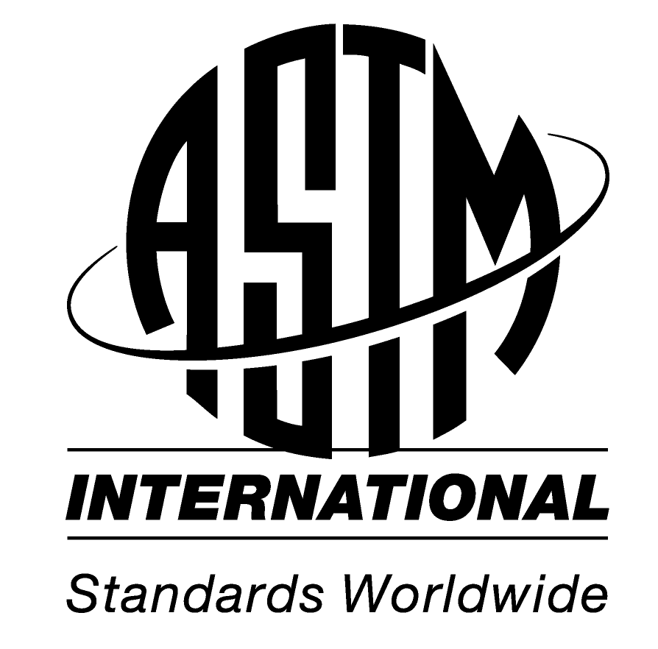
 |  |  |  |  |  | Address 100 Barr Harbor Drive  PO Box C700  W. Conshohocken, PA  19428-2959 | USA | Phone 610.832.9500  Fax 610.832.9555  e-mail service@astm.org  Web www.astm.org
 |  | Committee D19 Water
 | Chair: |  |  | William Lipps, Shimadzu, e-mail: wclipps@shimadzu.com
 | Vice Chair: |  |  | Jay Gandhi, Metrohm e-mail: jgandhi@metrohmusa.com
 | Secretary: |  |  | Anne Jurek, EST Analytical, e-mail: ajurek@estanalytical.com
 | Membership Secretary: |  |  | Mary McBride, Agilent, email: mary_mcbride@agilent.com
 | Staff Manager: |  |  | Brian Milewski, ASTM, 610-832-9619 email: bmilewski@astm.org
 | Admin assistant: |  |  | Lisa Drennen, ASTM, email: ldrennen@astm.org
TO: Stake Holders in ASTM Committee D19 Water

FROM: D19 Executive Committee
SUBJECT: Membership

We would like to personally welcome and thank you for joining the ASTM D19 Water committee. The ASTM D19 Committee on Water was formed in 1932 by a small group of scientists who faced similar challenges of analysis, description, and treatment of water with no standard methods to guide their work. Naturally, they turned to ASTM and established the committee along with several subcommittees focused on solving these common problems. Over the years, the committee has grown, and the size and scope of the various subcommittees have changed, but Committee D19 still meets its primary functions described below. The areas of interest of the committee are:

- The development of standard methods for sampling, identification, and analysis of:
  - Water and the materials dissolved or suspended in or formed from water, including physical, chemical, biochemical, radiochemical, and microbiological characteristics.
  - Communities of indigenous and other aquatic organisms.
- The development of standard methods for hydraulic and hydrologic measurements of surface and ground waters.
- The development of standard methods for evaluation of the performance of materials used to modify the characteristics of water, including selective, partial, or total removal of dissolved or suspended constituents and ion interchange.
- The development of standard methods for determining the corrosivity or deposit-forming properties of water.
- The designation of terminology, units of measurement, and precision and accuracy of tests pertaining to water.

ASTM D19 meets twice a year, usually in January and June, with up to four days of technical meetings and occasional workshops or symposiums on relevant topics. We are at the forefront of analytical standards development, often being the first to publish new methods based on new or improved technology. In addition to our method specific subcommittees we have also established subcommittees designed for collaboration with federal agencies, such as D19.90.04 US EPA /ASTM, and external standardization bodies, such as D19.95 International standards coordination with ISO TC147. Our members represent a broad spectrum of water analysis professionals, including laboratory analysts and managers, instrument manufacturers, consultants, academia, and numerous, relevant, federal and state agencies, such as EPA, USGS, LANL, and others. You can learn more including our scope, future meetings, past symposia, standards development and much more at our website. www.astm.org/ or from the link Committee D19 on Water

We have made a goal of increasing general meeting attendance and hope that this short letter has demonstrated the benefit of membership in the committee and the importance of general meeting attendance. If you have any questions, concerns or comments please feel free to contact us by e-mail .

Thank You for your interest in D19, and we look forward to seeing, and working with you,

Sincerely,
ASTM D19 Executive Committee

